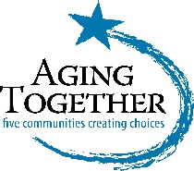
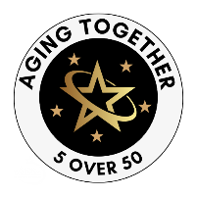

CALL FOR NOMINATIONS

5 OVER 50 CELEBRATION
May, 2025

The 5 Over 50 Celebration was created by Aging Together to highlight the significant contributions of adults to our communities and is aligned with National Older Americans Month in May each year.
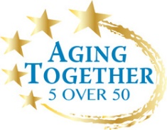
Every year in May, Aging Together awards one person from each of the five counties in our region who has made a significant contribution to their community. Honorees are nominated by those who have deep knowledge of their contributions and good citizenship. We are now seeking nominations from Culpeper, Fauquier, Madison, Orange, and Rappahannock Counties, for our 12th year celebration in May, 2025.

FINAL DEADLINE FOR SUBMISSION
JANUARY 10, 2025 - Aging Together will accept all nominations received on or before this date. If you have nominated someone in the past who was not chosen, you are welcome to nominate them again. Please submit a new form.

AWARD CRITERIA
- Must be over the age of 50
- Must live OR work in 1 of the 5 counties named above
- Has given and is still giving time freely in service to the community at large by civic engagement, and hence in some manner has made a significant contribution
- Has offered inspiration in the form of mentorship, leadership, or action
Use the questions on the following pages as a guideline for your narrative. Any nominations that are not deemed complete or that do not fulfill the award criteria may be automatically eliminated. One person from each county will be selected by committee. Thank you for writing a minimum of 300 words to describe your nominee. Please be as thorough as possible. Remember that, though you may know your nominee well, the decision committee does not and it is up to you to give them enough information to encourage their choosing that person. If only a short paragraph is submitted with few details about who they are they will not be chosen. The more details you can give, the better! Consider this a detailed introduction to get to know who this person is. Thank you!
Please return your nomination to info@agingtogether.org or mail to PO Box 367, Culpeper, VA 22701. Nominations are due by January 10, 2025 and those received after this date will not be considered.
Thank you!
NOTE:
This form is available to submit electronically on Aging Together’s website. We encourage online nominations for efficiency and easy submission.
Go to: www.agingtogether.org (see Events tab for more info).

5 Over 50 Nomination Form 2024
Name of person (or persons) submitting this nomination:

Phone Number (*required):

Email Address (*required):
Mailing Address of person submitting this nomination (required):
Preferred contact method?

Email _______ Phone _______

WHO ARE YOU NOMINATING?
Name of person being nominated:

Phone Number of nominee (*required):

Email Address of nominee (*required):
Mailing Address of nominee (required):
Which County are you submitting this nomination for (please circle one)?

CULPEPER FAUQUIER MADISON ORANGE RAPPAHANNOCK

Please continue to Page 3.

WHY ARE YOU NOMINATING THIS PERSON?

USE ADDITIONAL PAGES AS NECESSARY TO PROVIDE A COMPREHENSIVE SUBMISSION. THANK YOU!

- Be specific about ways this person has given to the community and describe any contributions they have made (outside of their job if employed). For example, do they volunteer significant time and resources? Are there ways they have been a catalyst for positive change? Are they a good mentor? Have they become involved in challenges that positively affect the region? Please use a minimum of 300 words and be as detailed as possible. Use additional pages if necessary.

- Please let us know of any organizational affiliations or volunteer work in which the nominee participates, or has in the past?

- Do you have any good stories about this person, or is there something about them no one else may know? Why should the nominating committee choose this person over others when they don’t know them?

Please return your nomination to info@agingtogether.org or mail to PO Box 367, Culpeper, VA 22701 by January 10, 2025. Thank you!

